**Lab 10**

* **Question 1:**
* **Source code:**

#include <stdio.h>

int sum(int n)

{

int digit=n%10;

n=n/10;

if (digit == 0)

return 0;

else

return digit+sum(n);

}

int main()

{

int num ;

printf("Enter a number: ");

scanf("%d",&num);

printf("Sum of digits is %d\n", sum (num));

return 0;

}

* **Output:**

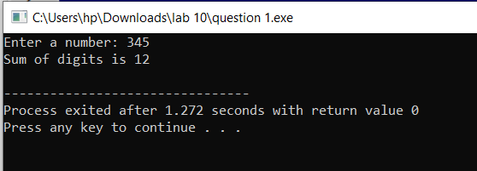

* **Question 2:**
* **Source code:**

#include <stdio.h>

#include <string.h>

void reverse(char str[],int start, int end)

{

if(start>=end)

return;

char temp=str[start];

str[start]=str[end];

str[end]=temp;

reverse(str,start+1,end-1);

}

int main()

{

char str[100];

printf("Enter a string to reverse: ");

scanf("%s",str);

str[strcspn(str,"\n")]=0;

int length=strlen(str);

reverse(str,0,length-1);

printf("Reversed string: %s\n",str);

}

* **Output:**

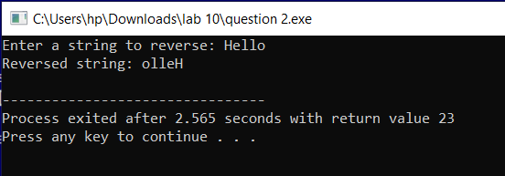

* **Question 3:**
* **Source code:**

#include <stdio.h>

struct flight {

int flight_num;

char depart_city[30];

char dest_city[30];

char date[10];

int seats;

};

int main()

{

int i, n;

struct flight details[50] = {

{101, "Karachi", "Lahore", "12112024", 20},

{102, "Karachi", "Islamabad", "15112024", 15},

{103, "Karachi", "Quetta", "09112024", 12}

};

int input;

for (i = 0; i < 3; i++)

{

printf("Flight ID %d: Departure city=%s, Destination city=%s, Date=%s, Seats=%d\n",

details[i].flight_num,

details[i].depart_city,

details[i].dest_city,

details[i].date,

details[i].seats);

}

printf("Enter flight ID: ");

scanf("%d",&input);

printf("Enter number of seats to book: ");

scanf("%d",&n);

for (i=0;i<3;i++)

{

if(details[i].flight_num==input)

{

(details[i].seats)-=n;

printf("Your %d seats has been booked for %d flight\n",n,details[i].flight_num);

}

}

for (i = 0; i < 3; i++)

{

printf("Flight ID %d: Departure city=%s, Destination city=%s, Date=%s, Seats=%d\n",

details[i].flight_num,

details[i].depart_city,

details[i].dest_city,

details[i].date,

details[i].seats);

}

}

* **Output:**

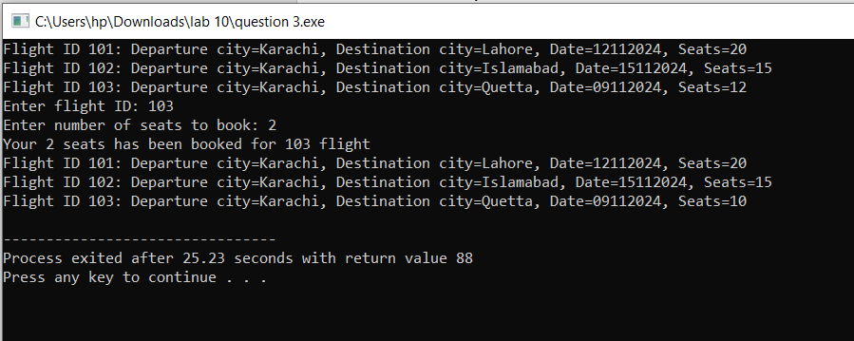

* **Question 4:**
* **Source code:**

#include <stdio.h>

#include <string.h>

struct movies {

char title[40];

char genre[30];

char director_name[30];

int release_year;

int rating;

};

int main()

{

int i, n;

char input[20];

struct movies details[50] = {

{"Harry potter", "Fantasy", "Alfonso Cuaron", 2001, 4.5},

{"Matilda", "Fiction", "Dann Devito", 1996, 4.5},

{"Charlie and the chocolate factory", "Fantasy", "Tim Burton", 1964, 5}

};

printf("Adding new movies\nSearch for movies by gnere\nDisplay movie details\nSelect from 1-3: ");

scanf("%d", &n);

getchar();

switch(n)

{

case 1:

printf("Enter movie title: ");

gets(details[3].title);

printf("Enter genre: ");

gets(details[3].genre);

printf("Enter director name: ");

gets(details[3].director_name);

printf("Enter release year: ");

scanf("%d", &details[3].release_year);

printf("Enter rating of movie: ");

scanf("%d", &details[3].rating);

for (i = 0; i < 4; i++)

{

printf("Title %s: genre=%s, director name=%s, release year=%d, rating=%d\n",

details[i].title,

details[i].genre,

details[i].director_name,

details[i].release_year,

details[i].rating);

}

break;

case 2:

printf("Enter genre to search: ");

scanf("%s",input);

for (i = 0; i < 3; i++)

{

if (strcmp(details[i].genre, input) == 0)

printf("%s\n", details[i].title);

}

break;

case 3:

for (i = 0; i < 3; i++)

{

printf("Title %s: genre=%s, director name=%s, release year=%d, rating=%d\n",

details[i].title,

details[i].genre,

details[i].director_name,

details[i].release_year,

details[i].rating);

}

break;

}

return 0;

}

* **Output:**

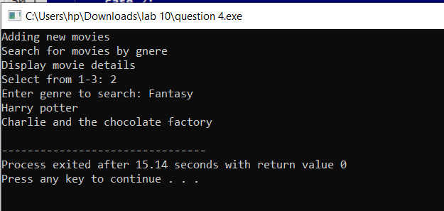

* **Question 5:**
* **Source code:**

#include <stdio.h>

void func(int arr[], int size) {

if (size == 0) {

return;

}

printf("%d\n", arr[0]);

func(arr + 1, size - 1);

}

int main() {

int n,i;

printf("Enter size of array: ");

scanf("%d",&n);

int arr[n];

for (i=0;i<n;i++)

{

printf("Enter value %d: ",i+1);

scanf("%d",&arr[i]);

}

func(arr, n);

return 0;

}

* **Output:**

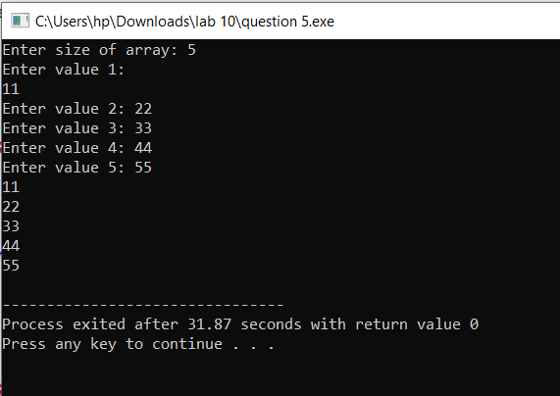

* **Question 6:**
* **Source code:**

#include <stdio.h>

#include <math.h> // For sqrt function

struct Point {

int x;

int y;

};

double distance(struct Point p1, struct Point p2) {

int delx = p2.x - p1.x;

int dely = p2.y - p1.y;

return sqrt(delx * delx + dely * dely);

}

int check(struct Point point, struct Point topleft, struct Point bottomright) {

if (point.x >= topleft.x && point.x <= bottomright.x &&

point.y <= topleft.y && point.y >= bottomright.y) {

return 1;

} else {

return 0;

}

}

int main()

{

struct Point point1, point2;

printf("Enter x and y coordinates for Point 1: ");

scanf("%d %d", &point1.x, &point1.y);

printf("Enter x and y coordinates for Point 2: ");

scanf("%d %d", &point2.x, &point2.y);

double dist = distance(point1, point2);

printf("Distance between Point 1 and Point 2: %f\n", dist);

struct Point topleft, bottomright;

printf("Enter top-left corner (x y) of the rectangle: ");

scanf("%d %d", &topleft.x, &topleft.y);

printf("Enter bottom-right corner (x y) of the rectangle: ");

scanf("%d %d", &bottomright.x, &bottomright.y);

if (check(point1, topleft, bottomright))

printf("Point 1 is inside the rectangle.\n");

else

printf("Point 1 is outside the rectangle.\n");

if (check(point2, topleft, bottomright))

printf("Point 2 is inside the rectangle.\n");

else

printf("Point 2 is outside the rectangle.\n");

return 0;

}

* **Output:**

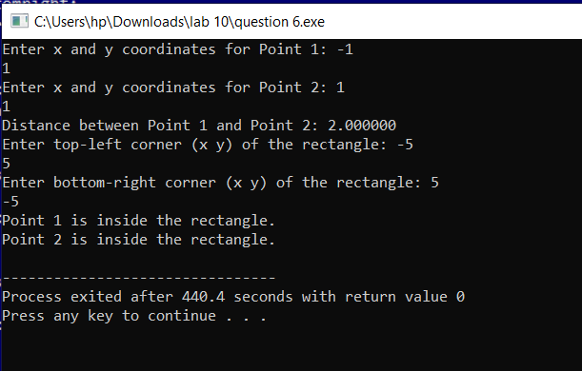

* **Question 7:**
* **Source code:**

#include <stdio.h>

#define max 100

void checktemp(int temp) {

static int count = 0;

if (temp > max) {

count++;

printf("Temperature %d exceeds the maximum allowable temperature!\n", temp);

} else {

printf("Temperature %d is within the allowable limit.\n", temp);

}

printf("Number of exceedances so far: %d\n", count);

}

int main() {

int n,i;

printf("Enter the number of temperatures to check: ");

scanf("%d", &n);

int temp[n];

for (i = 0; i < n; i++) {

printf("Enter temperature %d: ", i + 1);

scanf("%d", &temp[i]);

}

for (i=0;i<n;i++)

{

checktemp(temp[i]);

}

return 0;

}

* **Output:**

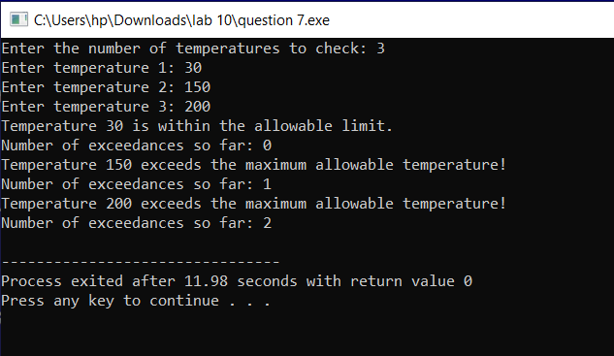

* **Question 8:**
* **Source code:**

#include <stdio.h>

#include <string.h>

struct cars {

char make[40];

char model[30];

int year;

int price;

int mileage;

};

int main()

{

int i, n;

char input[20];

struct cars details[50] = {

{"Germany", "X2", 2000, 200000, 30},

{"Japan", "S3", 2015, 500000, 50},

{"Pakistan", "A5", 2012, 1000000, 100}

};

printf("Adding new cars\nSearch for cars by make\nSearch for cars by model\nDisplay car details\nSelect from 1-4: ");

scanf("%d", &n);

getchar();

switch(n)

{

case 1:

printf("Enter car make: ");

gets(details[3].make);

printf("Enter model: ");

gets(details[3].model);

printf("Enter year: ");

scanf("%d", &details[3].year);

printf("Enter price: ");

scanf("%d", &details[3].price);

printf("Enter mileage: ");

scanf("%d", &details[3].mileage);

for (i = 0; i < 4; i++)

{

printf("Make %s: model=%s, year=%d, price=%d, mileage=%d\n",

details[i].make,

details[i].model,

details[i].year,

details[i].price,

details[i].mileage);

}

break;

case 2:

printf("Enter make to search: ");

scanf("%s",input);

for (i = 0; i < 3; i++)

{

if (strcmp(details[i].make, input) == 0)

printf("Model: %s\n", details[i].model);

}

break;

case 3:

printf("Enter model to search: ");

scanf("%s",input);

for (i = 0; i < 3; i++)

{

if (strcmp(details[i].model, input) == 0)

printf("Make: %s\n", details[i].make);

}

break;

case 4:

for (i = 0; i < 3; i++)

{

printf("Make %s: model=%s, year=%d, price=%d, mileage=%d\n",

details[i].make,

details[i].model,

details[i].year,

details[i].price,

details[i].mileage);

}

break;

}

return 0;

}

* **Output:**

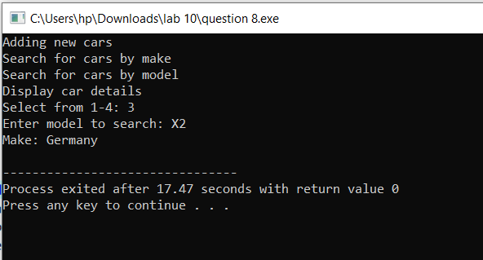

* **Question 9:**
* **Source code:**

#include <stdio.h>

void bubbleSort(int arr[], int n)

{

if (n == 1)

{

return;

}

int i;

for (i = 0; i < n - 1; i++)

{

if (arr[i] > arr[i + 1])

{

int temp = arr[i];

arr[i] = arr[i + 1];

arr[i + 1] = temp;

}

}

bubbleSort(arr, n - 1);

}

int main()

{

int n,i;

printf("Enter the number of elements in the array: ");

scanf("%d", &n);

int arr[n];

printf("Enter the elements of the array:\n");

for (i = 0; i < n; i++) {

scanf("%d", &arr[i]);

}

bubbleSort(arr, n);

printf("Sorted array:\n");

for (i = 0; i < n; i++)

{

printf("%d\n", arr[i]);

}

return 0;

}

* **Output:**

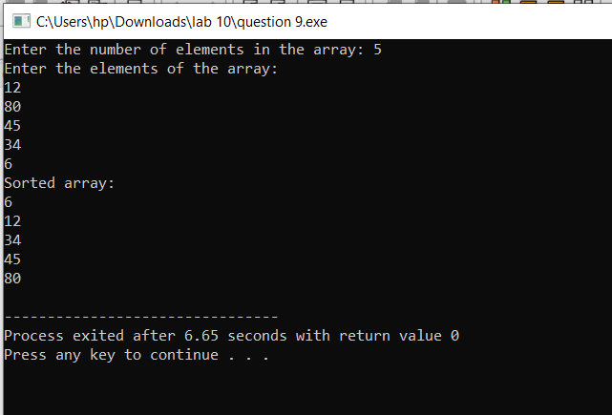

* **Question 10:**
* **Source code:**

#include <stdio.h>

#include <string.h>

struct travel

{

char name[30];

char dest[30];

int duration;

int cost;

int seats;

};

int main()

{

struct travel package[50]={

{"Umrah","Saudia Arab",5,1000000,10},

{"Honeymoon","Dubai",3,600000,15},

{"Pakistan tour","Naran",1,300000,8}

};

int i,n;

char input[30];

for (i = 0; i < 3; i++)

{

printf("Name %s: Destination=%s, Duration=%d, Cost=%d, Seats=%d\n",

package[i].name,

package[i].dest,

package[i].duration,

package[i].cost,

package[i].seats);

}

printf("Enter package name: ");

gets(input);

printf("Enter number of seats to book: ");

scanf("%d",&n);

for (i=0;i<3;i++)

{

if(strcmp(package[i].name,input)==0)

{

(package[i].seats)-=n;

printf("Your %d seats has been booked for %s package\n",n,package[i].name);

}

}

for (i = 0; i < 3; i++)

{

printf("Name %s: Destination=%s, Duration=%d, Cost=%d, Seats=%d\n",

package[i].name,

package[i].dest,

package[i].duration,

package[i].cost,

package[i].seats);

}

}

* **Output:**

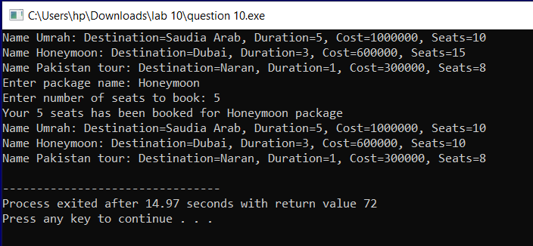

* **Question 11:**
* **Source code:**

#include <stdio.h>

#define base 0.001

float func(float dis)

{

static int count=0;

count++;

printf("Function called %d times\n",count);

return dis*base;

}

int main()

{

while(1)

{

float dis;

printf("Enter distance in meters:(0 to quit) ");

scanf("%f",&dis);

if(dis==0)

break;

float km = func(dis);

printf("Distance in kilometers is: %f\n",km);

}

}

* **Output:**

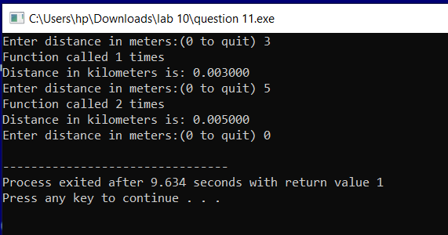

* **Question 12:**
* **Source code:**

#include <stdio.h>

int linearsearch(int arr[], int size, int target, int index) {

if (index == size) {

return -1;

}

if (arr[index] == target) {

return index;

}

return linearsearch(arr, size, target, index + 1);

}

int main() {

int n, i, target;

printf("Enter number of elements in array: ");

scanf("%d", &n);

int arr[n];

for (i = 0; i < n; i++) {

printf("Enter element %d: ", i + 1);

scanf("%d", &arr[i]);

}

printf("Enter target element: ");

scanf("%d", &target);

int result = linearsearch(arr, n, target, 0);

if (result != -1) {

printf("Element %d found at index %d.\n", target, result);

} else {

printf("Element %d is not found in the array.\n", target);

}

return 0;

}

* **Output:**

